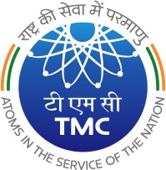
TATA MEMORIAL CENTRE
c

TATA MEMORIAL HOSPITAL
(A Grant-in Aid Institute under Dept. of Atomic Energy, Govt. of India)

DR. E. BORGES MARG

PAREL, MUMBAI 400012

04/05/2023
CPP Portal Tender Notice 5 - Corrigendum II

Sub: CPP Portal Tender Notice No. 05 for supply of “Digital PET/CT Scanner Qty: 03 Nos. (Qty: 02 Nos. for TMH and Qty:01 No. for ACTREC) for Nuclear Medicine Dept, TMH & ACTREC.

Please visit CPP Portal website for details of tender floated for: Digital PET/CT Scanner Qty: 03 Nos. (Qty: 02 Nos. for TMH and Qty: 01 No. for ACTREC) for Nuclear Medicine Dept., TMH & ACTREC.

Revised Technical specifications and NIT after Pre-bid meeting uploaded on CPP Portal.

Tender Ref No : TMH/TMC/2022-23/CAP/PT/0060
Tender ID : 2023_TMC_734168_1

Last Date and time of Tender Submission: 30/05/2023 up to 2.00 p.m.

Date and time of opening of Part I Technical Bid: 31/05/2023 at 2.30 p.m. onwards.

PURCHASE OFFICER

